Beta Sigma Psi
3.8
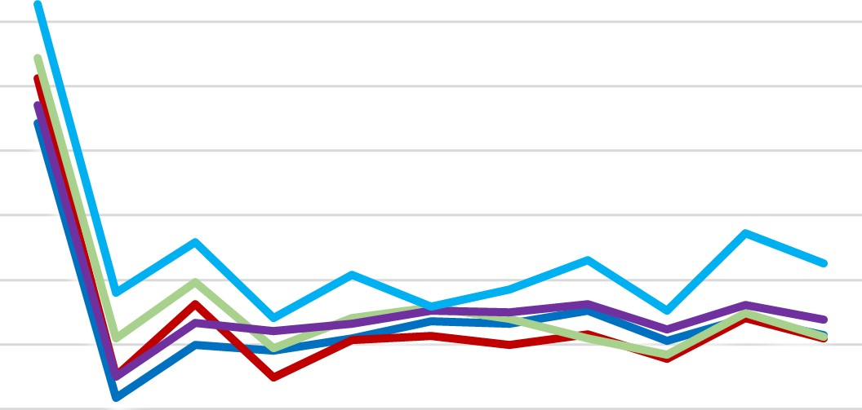
  All Male
  —All IFC
  All Greek
  All Student
  Sigma Psi
3.7
3.6
3.5
3.4
3.3
3.2
3.1
3
2.9

S20 F20 S21 F21 S22 F22 S23 F23 S24 F24 S25

